150907-5252-0751

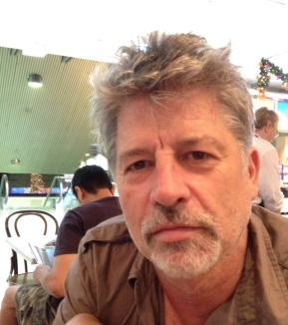

I spent my first 20 years growing up in the City of Gosnells and have been here again for the last five. I am married, have grown children and was a career academic – in the fields of politics and applied policy. My last ten years of university employment were spent at the Institute for Sustainability and Technology Policy at Murdoch researching and teaching postgraduate courses in city planning and development theory. Though retired, I continue to write and have become a small-scale land developer. Now it’s hands-on urban development! Two current planning issues particularly concern me:

* The State Government’s careless infill development plans threatening the quality of life in middle and outer suburbs across Perth, especially the Albany Highway corridor.
* The unfairly favourable treatment of the inner city.

I stand for better suburbs and a better deal for the residents of the City of Gosnells. For more, visit petervintila.com